Instructor Evaluation Summary Worksheet Instructions
This document provides basic information on how to complete the Instructor Evaluation Summary Worksheet and where to submit it.
If further guidance is required, contact APICS at idpapps@apics.org.
Getting Started: You should have the student evaluations from each course that you taught and the most recent version of the Instructor Evaluation Summary Worksheet which is located in the Instructor Development Community Library.
For each course that you taught, you only need to complete the first two (2) tabs (yellow tabs):
- Input Course Info
- Input Scores
Complete Input Course Info tab: An instruction box appears to identify information that is required for each field. Be sure to read the instructions in each box to provide the requisite information.

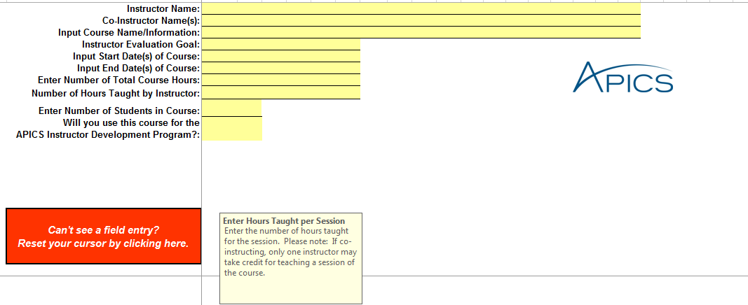

Complete Input Scores tab: populate each column with the responses from individual participants.
- Each column represents the responses from each student-evaluator. For example, if six (6) students responded, then you should complete 6 columns to correspond to the students’ responses to each area evaluated.

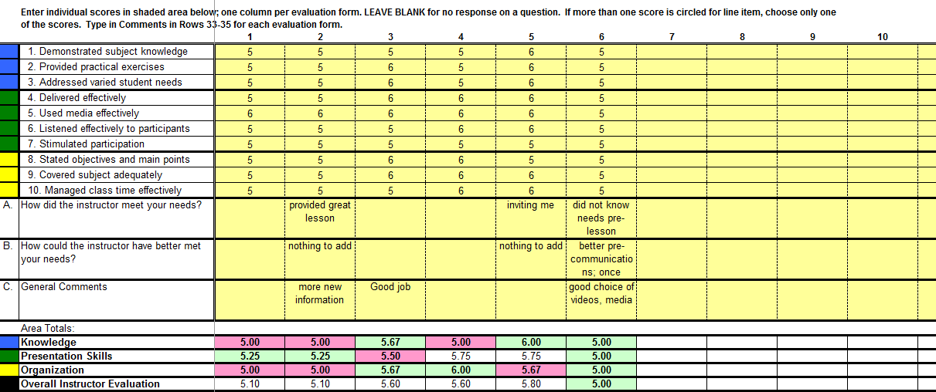

- Enter the individual scores for each area the student evaluated. Enter the score and comments in the column (yellow highlighted cells) next to each area evaluated. Note that the Area Totals are auto-populated based on the information inserted into the highlighted cells.

What are the green tabs for?
Both tabs are auto-populated, based on the information that you provide in the yellow input tabs. The Evaluation Comments tab is for your personal reference and development plan. The Evaluation Summary is part of your IDP Maintenance submission. For the purposes of IDP maintenance requirements, instructors only need to submit the Instructor Evaluation Summary for the classes that they are required to teach to maintain their recognition(s).

- Evaluation Comments: the first green tab provides a high-level overview of all the class participants’ comments for your quick reference of your strengths and your development areas.

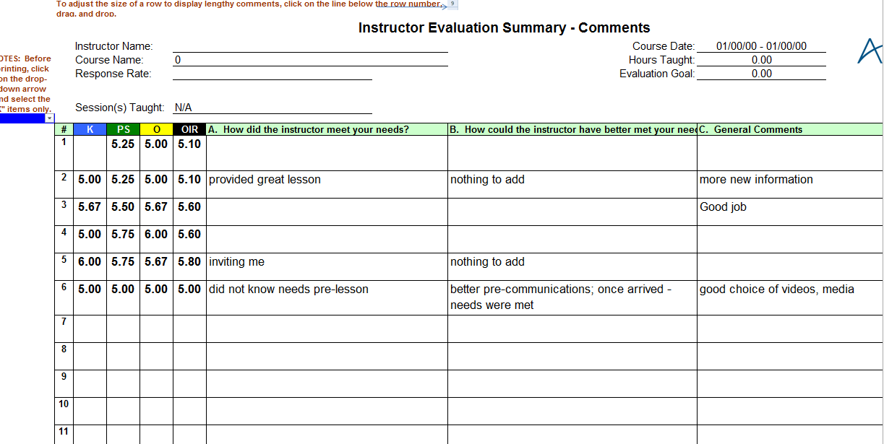

- Evaluation Summary: the second green tab provides a summary of each area evaluated (Knowledge, Presentation Skills, Organization) so the instructor can easily view his/her overall score for the class and quickly view his/her strengths and development areas
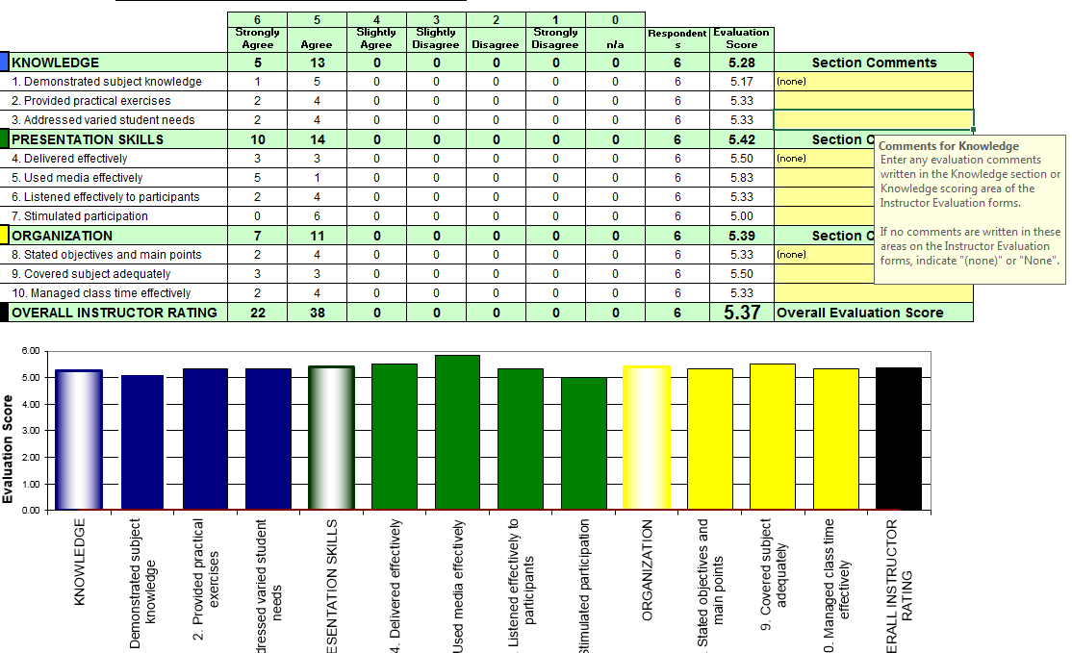
Submitting the Instructor Evaluation Summary Worksheet
When do I submit the evaluation summary worksheet? You submit it when you submit your Instructor Development Program (IDP) maintenance documents or when you wish to upgrade your instructor designation (e.g., from Associate to Lead instructor). You should also submit the evaluation summary to your chapter or partner, if required.
What information do I submit and to whom? Submit a PDF of the Evaluation Summary tab(s) to the APICS Professional Development department with your maintenance documents. Send your summaries to idpapps@apics.org. Your respective chapter or partner may also request the summaries to keep a log of the courses that you taught to maintain your recognition(s).

